# Acknowledgement

At first, we would humbly thank APU University to give us this assignment about the Learning Management System. This project surely has helped us to gather the information and we’ve been thankful to present our little bit of information regarding the Learning Management System. This project has driven us to our full potential to gather the data to present this Assignment. We’ve got some concepts which we’ve never ever heard something about or not even learnt. We can assure that through our assignment we’ve learned so many things which we may apply in our upcoming days.

Surely, this assignment could never have been completed without the instruction and advice through our respected subject teacher Miss Saya Joshi. Through our heart we would like to gratitude our teacher for giving us the idea and concepts regarding the assignment. Since, I would also like to thank all of our team members who have been doing this assignment with all their effort. Every member has some of their role in this assignment which they have explained their part through their point of view. So, at last we’ve gathered every possible data regarding our assignment which has been described above in the table of content.

# Introduction

Your Dream was established in 2021, as an e-Learning platform whose motto is to improve the learning or study method globally wise. The change in the present world has gathered various demands and necessities for various things. One of them includes the way of observing and gathering information through education. Though, in this present society many names have been known worldwide. Those names have also learnt about something that quite usual for others, but they have gathered something very important. So, the education has played an important role in the world. There’s been various ways to improve the education system but that doesn’t help to understand many people. Various University have started to provide the e-learning through Learning Management System (LMS).

To ensure and make the education system an effective way for the students to understand our company has started implementing through e-learning. The higher the studies the higher the education is required for the students. To provide higher education our company has that potential for providing the students with a challenge and possibilities to do something extraordinary. Our company has the potential that drives its students rapidly through improving their ability to acquire knowledge. Many people have visited our company of the online education to get something essential for acquiring important skills through simply visiting this website. You can easily gather information while sitting in a room or even when you are far from your house 24/7. Our company can deliver information to various people without crashing websites. Our company has grown so fast till these days the company which have started with only four members. There’s no doubt that this has gained so many employees, which has made this company climb to the top of the success ladder.

**Name**: Your Dream

**Logo**:



**Vision:** To bring horizon in the online learning system and to change the basic learning system globally and provide e-learning in every college and university.

**Motto:** To inspire people for guiding them to a better learning platform. To ensure productive change in the quality of education.

# Business process and its overview proposed system.

Your Dream aims to provide its user with a way that they can easily get any kind of problem solution in ease without the server crash. It also allows the user to access the recommended part that is related to their problem. The Learning Management System maintains the data and their login and logout details also. This system provides a framework for the data of employees like delivering the data and information. It collects the data and supervises it in a simpler form. It provides the necessary online courses whenever the user wants to have the information in a simple worksheet of the data. The proposed system’s main objective is to maintain the data and gather it in a safe place for providing new courses in a simplified method. It manages the content of the courses easily so that the user can recognize it properly.

## Objective

The learning management system has many official works which aim forward for managing the way of learning easily through e-learning. The main objective of this system is to make the complicated method of study into a simple way of acquiring education. The learning management system’s objective is to provide the users with the pre-defined meaning and solution of their problem-related questionnaire. The more users search for that problem the more it gives the better solution. Our system is quite handy and easy to get the appropriate solution. It’s a learning platform whose objective is to make the way of recognizing the information by gathering every possible solution and outcome for the problem.

# Problem and Proposed System

## Current System problem

1. Lack of business plan and proposal:

A business plan and proposal are the key factors that show the business’s future and its work. A good plan and proposal help in the development of the company whereas a lack of business plans and proposals can even destroy a company or be bankrupt. The “Your Dream” company is running a problem because of a lack of plan, proposal, and adapting it. The causes of this problem are:

* Bad idea
* Laziness in the employee
* Imbalanced team
* Budget finalizing
* Lack of analyzing the current problem and planning to improvement

The effect of this problem on the company are:

* A bad idea while giving a presentation can create a loss of time and effort while creating the project as it becomes a loss of time for management for the entire employee.
* As an E-learning company, we need to create a great plan for the development of the company but the laziness in workers can reschedule the deadline again and again which is a great loss for the company management.
* As creating the plan and proposing it is done by the entire group not by the individual, thus imbalance team can coordinate properly nor give their best while creating a project and plan.
* As the company is in development, the most important factor is the budget thus if the budget is not finalized properly then it can create economic problems in E-leaning.
* As a most important component for the worker is to analyze the current system and propose a plan document for the company but if the worker focuses on another factor then that problem can create problems in future reference.

**Some of the Solutions for the above point:**

* Not all bad ideas can be worse thus suggesting the worker and improving their work can be profitable for the company.
* As for the growth of the company, the worker must be active and complete the work by the given deadline thus the lazy worker who does not do the work properly can be fired from the company.
* Creating a team for the best of their work, capacity, and knowledge makes coordination and presentation easier.
* Creating an analysis group for the budget finalization can utilize the money and make it easier for the work to be implemented.
* Making a group to identify the problem of the company can make the management easy and easy to implement and execute the plan for the development. Which could make it easy for the company to run.

1. Lack of study material

A scarcity of resources Students' learning is aided significantly by resource materials. When resource materials are used wisely, they significantly improve the impact of the lesson. The availability of a wide range of instructional resources can pique learners' interest and actively engage them in the learning process.​ (bartleby, 2023)

Causes

* Insufficient technological infrastructure (elearningindustry, 2023)
* Budget restrictions  (elearningindustry, 2023)
* Inadequate internet access  (elearningindustry, 2023)
* Policy considerations for eLearning (elearningindustry, 2023)

Effect

* Students may experience extreme distress because of a lack of resources. (bartleby, 2023)
  + They are not being provided with the necessary resources, which prevents them from learning to their full potential.​ (bartleby, 2023)

Solution

* adequate technology infrastructure. (bartleby, 2023)
* adequate internet connection. (bartleby, 2023)
* Policy considerations for eLearning. (bartleby, 2023)
* Teaching personnel must receive training.​ (bartleby, 2023)

**Scope**

Provide Learning materials that support learning can significantly increase learners' achievement. An educational video, for example, may provide a learner with new insights, while an appealing worksheet may provide the learner with new opportunities to practice a new skill learned in class.​ (open, 2023)

**Objective**

The purpose and significance of teaching and learning materials are to make lessons more interesting, learning easier, and allow teachers to express concepts more easily. Learning materials that support learning can significantly increase learners' achievement.​ (open, 2023)

1. Traditional Management system

A teaching and learning pedagogy that focuses on a model in which the teacher first lectures or introduces new content, then gradually allows students to practice, and then has students complete independent activities on their own, often as homework outside of the classroom. As long as it takes place in a traditional, face-to-face setting, it can include both direct and indirect forms of learning.

Causes

* Time-Bound: involves a strict schedule that is difficult to adjust as needed.
* High cost: high infrastructure and maintenance costs.
* Generic Methodologies: employ generic teaching methods that are not learner specific. Due to time constraints, theory-based lessons predominate over activity-based lessons.
* Physical presence of teacher and learner: both the teacher and the learners must be present under the same roof.

Effects

It has an impact on the time of students and teachers because they must be physically present rather than virtually. It not only affects the time, but it also affects the important data that is saved in a physical file in the event of an emergency or natural disaster.

Solution

So, the simple solution to the traditional management system is to use an eLearning platform, which will be extremely beneficial to both teachers and students because it does not have any high costs, time constraints, or physical presence.

1. Scheduling and management:

It is an important function to schedule the business plan because it helps to ensure our time where and when we are busy or free. Scheduling helps to maintain proper discipline in a certain organization, office, and business sector. Many students and teachers must have a schedule to have management in the learning sessions. It manages the schedule of a certain routine of time with ease.

**Causes**

1. The causes of scheduling and management are lack of responsibility and management of time of the students and teachers also. Though in e-learning time management is important to acquire a certain goal and objective for achieving the deeds. Many students and the teachers are irresponsible and while maintaining time they always end up with some problems and difficulties.

**Effect**

1. Due to laziness and improper sleeping routine, people end up in less time to manage their lifestyle in proper order. The main effect is social media and games. They are all fed by this new generation. Some of them were so much addicted to this thing that they might even fight anyone to get that certain thing. Due to this kind of thing many of the students aren’t able to maintain their schedules.
2. Proposed solution

Having a plan is important for the students and the teachers to do the required time for other activities. Thus, everyone must have a timetable and implement the time to have an essential gathering time for the other work. Due to the scheduling, it is essential to finish the work without the fear of deadlines. Prioritizing the time you have spent and utilizing the remaining time to maintain the documents. Daily following the same routine, it is quite important for the students to follow up the routine and implement the time in an appropriate order.

**4. User attraction**

1. Cause and effect:

It will be challenging to approach students as there are many other e learning platforms with different opportunities. Consciously companies can face less attraction from users. Different courses vary between different users which creates difficulties attracting targeted users and unwanted users.

1. Solution:

To overcome this, we need to come up with a good strategy that carries the ability to attract more people. Such as promoting and advertising on huge range of area. Conducting surveys on different levels of user helps to come up with good ideology to approach many targeted users.

5. Quality of instructions

1. Causes and effects:

There would be different experiences between traditional classroom teaching methods and e learning platform which might create a bad impression. As well as resources regarding different course of e learning platform could not deliver the corresponding quality of instructions and impact on the user

1. Solution:

Creating an effective virtual instructor allows users to understand course with good feedback. Providing sufficient resources and facilities can generate huge improvements.

# Project Planning

## Identify and explain the task and activities.

|  |  |
| --- | --- |
| **Module Name** | **System Analysis and Design** |
| **Module Code** |  |

|  |  |  |  |  |
| --- | --- | --- | --- | --- |
| **Student Name** | **Pramod Adhikari** | **Maulik Shahi Thakuri** | **Sampanna Adhikari** | **Rigzeen Sherpa** |
| **Roll no.** | **NP069472** | **NP069464** | **NP069483** | **NP069476** |

|  |  |  |
| --- | --- | --- |
| **S.N.** | **Tasks** | **Student name** |
| **1.** | Introduction | **Sampanna Adhikari** |
| **2.** | Problem & proposed solution | **All** |
| **3.** | Project Planning | **Pramod Adhikari** |
| **4.** | Feasibility Study | **Maulik & Rigzeen** |
| **5.** | System Analysis | **All** |
| **6.** | Design a Diagram | **Pramod Adhikari** |
| **7.** | Interface Design | **Pramod Adhikari** |
| **8.** | Requirement Gathering | **All** |
| **9.** | Design | **Rigzeen &Sampanna** |
|  | Total | **All the members helped each other** |

## Gantt chart

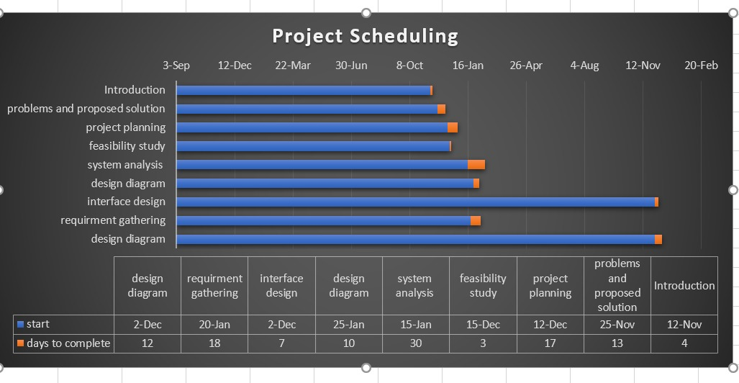 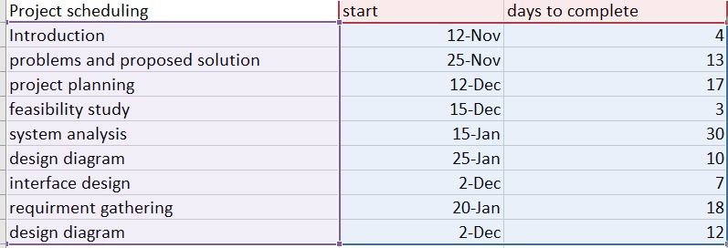

## Workload matrix

|  |  |  |  |  |
| --- | --- | --- | --- | --- |
| **Student Name** | **Pramod Adhikari** | **Maulik Shahi Thakuri** | **Sampanna Adhikari** | **Rigzeen Sherpa** |
| **Roll no.** | **NP069472** | **NP069464** | **NP069483** | **NP069476** |

|  |  |  |  |  |  |  |  |
| --- | --- | --- | --- | --- | --- | --- | --- |
| **S.N.** | **Tasks** | **Duration** | **Contribution Percentage** | | | | **Total** |
| **NP069472** | **NP069464** | **NP069483** | **NP069476** |
| **1.** | Introduction | 5 | 5% | 5% | 75% | 5% | 100% |
| **2.** | Problem & proposed solution | 9 | 25% | 25% | 25% | 25% | 100% |
| **3.** | Project Planning | 5 | 40% | 20% | 20% | 20% | 100% |
| **4.** | Feasibility Study | 5 | 5% | 45% | 5% | 45% | 100% |
| **5.** | System Analysis | 6 | 25% | 25% | 25% | 25% | 100% |
| **6.** | Design a Diagram | 8 | 70% | 10% | 10% | 10% | 100% |
| **7.** | Interface Design | 4 | 70% | 10% | 5% | 5% | 100% |
| **8.** | Requirement Gathering | 6 | 25% | 25% | 25% | 25% | 100% |
| **9.** | Design | 5 | 10% | 20% | 30% | 40% | 100% |
| **10.** | Involvement and assist | 3 | 25% | 25% | 25% | 25% | 100% |
|  | Total |  | 30.5% | 22% | 24.5% | 23% | 100% |

# Feasibility Study

A feasibility study assesses the viability of a project or system. The objective and rational analysis of a potential business or venture is conducted as part of a feasibility study to determine its strengths and weaknesses, potential opportunities and threats, resources required to carry out, and ultimate success prospects. When determining feasibility, two factors should be considered: the required cost and the expected value.

A feasibility study is a comprehensive assessment of a proposed project that evaluates all critical success factors to determine its likelihood of success. Business success is primarily defined in terms of ROI, or the amount of profit generated by the project.​ (Simplilearn, 2023)​

## Operational

This assessment entails researching to determine whether—and how well—the organization's needs can be met by completing the project. Operational feasibility studies also look at how a project plan meets the requirements identified during the system development requirements analysis phase.​ (Simplilearn, 2023)​

## Technical

This assessment focuses on the organization's technical resources. It assists organizations in determining whether technical resources are adequate and whether the technical team is capable of translating ideas into working systems. Technical feasibility also includes an assessment of the proposed system's hardware, software, and other technical requirements. As an exaggeration, an organization would not want to try to install Star Trek transporters in their building—this project is currently not technically feasible.​ (Simplilearn, 2023)​

## Economical

Economic feasibility is the capacity of a project or investment to produce adequate financial returns to cover its expenses and risks. To ascertain whether a project is both financially feasible and useful, it includes weighing its costs and advantages. The economic aspect plays a significant and crucial role in the project's problem-solving process. Whether the project will continue or not in the future will depend on this. The project's strength and development were determined by economic variables. This includes assessing factors such as project cost, revenue, market demand, management issues and competition within the market.

The financial strategy for establishing the suggested framework is shown in the table below.

|  |  |  |  |
| --- | --- | --- | --- |
| Item | Specification | Quantity | Price (NRS) |
| 1.Server | * Server Board: * CPU * DIMM Slots:12 * Maximum Capcity:128GB * Memory:128GB * Hard Drives: 100TB * Form Factor: Tower(6U) | 1  1  1  1  1  1  1 | 190000 |
| 2.Desktop (PC) | * I9-12900KS * Memory:128GB * Hard Drive:1.5TB | 1  1  1 | 150000 |
| 3.Server Monitor | * Monita’s Cloud Server Monitoring | 1 | 45000 |
| 4.Security System | * Kaspersky Small Office Security | 1 | 76000 |
| 5.Internet | * NETGEAR * TP-LINK ARCHER AX600 * ASYS RT-AX88U | 1  1  1 | 70000 |
|  | Total |  | 531000 |

Coat maintenance

|  |  |  |  |
| --- | --- | --- | --- |
| Item | Specification | Quantity | Price (NRS) |
| 1.Hardware Upgrade and Maintenance | * Server Check-Up(annually) | 1 | 50000 |
| 2.Software Upgrade and Maintenance | * Herve Tech Office (Monthly) | 1 | 120000 |
| 3.Network Maintenance | * ASYS RT-AX88U * NETGEAR * Internet Package (500Mbps) annually |  | 240000 |
|  | Total |  | 410000 |

Payback Analysis

Development cost= 531000NRS+410000NRS=941000

Operational Cost(annually)= 410000NRS

|  |  |  |
| --- | --- | --- |
| Year | Cost (NRS) | Cumulative Cost (NRS) |
| 0 | 941000 | 941000 |
| 1 | 410000 | 1351000 |
| 2 | 410000 | 1761000 |
| 3 | 410000 | 2171000 |
| 4 | 410000 | 2581000 |
| 5 | 410000 | 2991000 |

Benefit Analysis

|  |  |  |
| --- | --- | --- |
| Year | Benefit (NRS) | Benefit Cost (NRS) |
| 0 | 0 | 0 |
| 1 | 520000 | 520000 |
| 2 | 805000 | 1325000 |
| 3 | 1400000 | 2725000 |
| 4 | 1800000 | 4525000 |
| 5 | 2500000 | 7025000 |

Payback Period

|  |  |  |  |  |  |
| --- | --- | --- | --- | --- | --- |
| Year | Cost (NRS) | Cumulative Cost for Benefits (NRS) | Benefits(NRS) | Cumulative Cost for Benefits (NRS) | Profit Earned (NRS) |
| 0 | 941000 | 941000 | 0 | 0 | -941000 |
| 1 | 410000 | 1351000 | 520000 | 520000 | -831000 |
| 2 | 410000 | 1761000 | 805000 | 1325000 | -436000 |
| 3 | 410000 | 2171000 | 1400000 | 2725000 | 554000 |
| 4 | 410000 | 2581000 | 1800000 | 4525000 | 1944000 |
| 5 | 410000 | 2991000 | 2500000 | 7025000 | 4034000 |

Total For Development and Operational(Annually Cost)= 2991000NR

Total For Benefits=7025000NRS

Return on Investment

ROI=

ROI= =134.9% Return in Investment

## Schedule Feasibility

|  |  |  |  |  |  |
| --- | --- | --- | --- | --- | --- |
| TASK | DATE | | | TASK ASSIGNED T0 : | |
| Identifying the present problem and prerequisites for the proposed framework | 10th January 2023-4th March 2023 | | | all members | |
| Discussed the suggested framework with the customer | 23rd January 2023-30th March 2023 | | | all members | |
| Making plans for the design | 16th March 2023-23rd May 2023 | | | all members | |
| Creating a Gantt chart and a workflow for the Gantt | 11th January 2023- 5th March. | | | Ashley Jones | |
| Figure out what the system requirements are | 10th May 2023-4th June | | | all members | |
| Handle critical information on the systems development depending on the client's needs | 18th November 2023-4th December | | | Don Francis | |
| Examine the methods to design development | 6th April 2023-4th May 2023 | | | all members | |
| Create a system diagram | 15th January 2023-12th March 2023 | | | Alexa Young | |
| Approval of the proposed systems diagram design | 18th September 2023-18th March 2023. | | | Robert Rose | |
| System testing | | 30th May 2023-4th March 2023. | All members | |
| provide the customer with a report on the planned system | | 23rd April 2023-May 23rd 2023 | All members | |
| confirm if the product solution meets the client’s requirement | | 18th March 2023-19th May 2023 | All members | | | |

## PIECES Framework:

P-Performance:

As the word, it says that its function is to show how the system is running. It is an important process of the given framework. Its main objective is to identify whether the system is working properly or may have some faults in it. In our system “E-learning” there may have errors and may slow down the performance of the work to minimize that we’ve improved the system in maintaining the system process through various examples like providing the user guidance on whether the system may lose its momentum. (bcisnotes, 2020)

I-Information:

The sentence itself says information means to share essential data about the system. Information means the data which is being shared among each other. Some of the basic information is as follows the user’s name, place, mobile number, email, etc. The information is a very important factor for the user because if the data is lost then the user might have some problems. To prevent that the system provides strong security for the user’s data. (bcisnotes, 2020)

E-Economy:

Economy means earned money or wealth. In our system, the built-in cost was low, which manages the economic expenses of our organization. The main objective of our current system is to manage the economic cost and status also we’ve got some of the essential’s part from the existing system which helped in the building of the current system. This also helped in the increment of revenue and making profits also helps in the control of the cost regarding the current system. (bcisnotes, 2020)

C-Control:

In the PIECES framework control plays an important role in the management of various works in the current system of “E-Learning” like having access to security development. It also decreases the risk factors and helps in cyber security. Control means to take over something that doesn’t have any balance in the current system. It manages the operational work smoothly and progressively. (bcisnotes, 2020)

E-Efficiency:

The term efficiency means carrying the plan and work in a series of orders. Efficiency is meant to be the exception in how the work is being completed. It describes how much earning can provide the services and benefits to the organizational goals. (Simplilearn, 2023)

S-Services:

Services are meant to be important aspects of our system. Services are meant to be the helping hand of someone. Services are provided especially to the user because it makes their work much easier and more efficient. The services to the user must be improved to give certain benefits to the organization and build a mutual relationship with the user which helps in promoting the organization through a certain referral. (bcisnotes, 2020)

# System Analysis

## Requirement gathering

1. **One-on-One Interviews:**

It is one of the most used ways of gathering information which is quite handy on this platform. It is generally done while sitting with the clients and asking whether there’s a fault in the current system or what’s the thing that’s bothering them this would change the system or something that might be essential. It’s a simple but effective way coz people easily reveal or always have something that says it lacks this or that so this might be the best way of gathering the information. (LISBDNETWORK, 2022)

1. **Group Interviews:**

It is kind of similar way like one-on-one, but it is done among a bunch of people usually more than one person. It’s easier to reveal and gather the information in a group because it doesn’t require more amount of time than the first one above. The more it’s easier to work so the group can gather the information ease within a very short time and also the people in the certain group can help us to gather the information while they are discussing the matter and finds a fault in each other’s statement and then we can get the information regarding something missing and something wrong in the system. (LISBDNETWORK, 2022)

1. **Joint Application Development:**

It’s like a group of people gathering the requirements that are needed in the improvement of the system by making documentation of the series of problems referring to the system’s backwardness. (LISBDNETWORK, 2022)

1. **Questionnaires:**

These are the casual ways of gathering the information by asking the people in the company about some of the minor faults in the system. It is a commonly used term in big companies or organizations. It is the gathering of information among many people of large amount like more than six or seven. (LISBDNETWORK, 2022)

# Design a Diagram

## Context diagram

## Level - 0 DFD

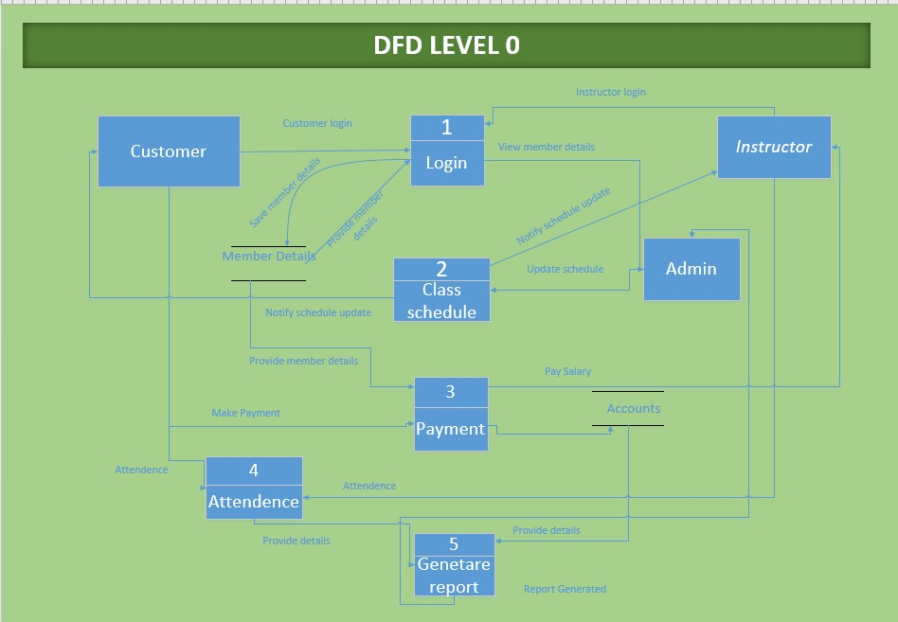

Fig: DFD level 0 diagram

## ERD

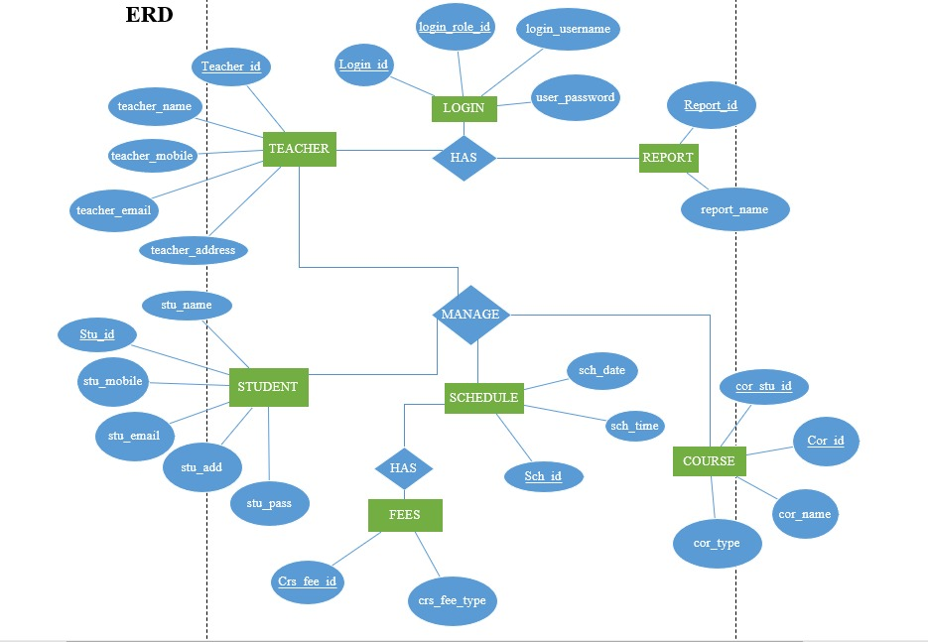

# Interface Design

## Design

As we login to our website a landing page appears and after some time a popup log in bottom appears in which you can log with Google, LinkedIn, Facebook, and GitHub account. This is a multi-authorization login for users, from which user can login to any one account. 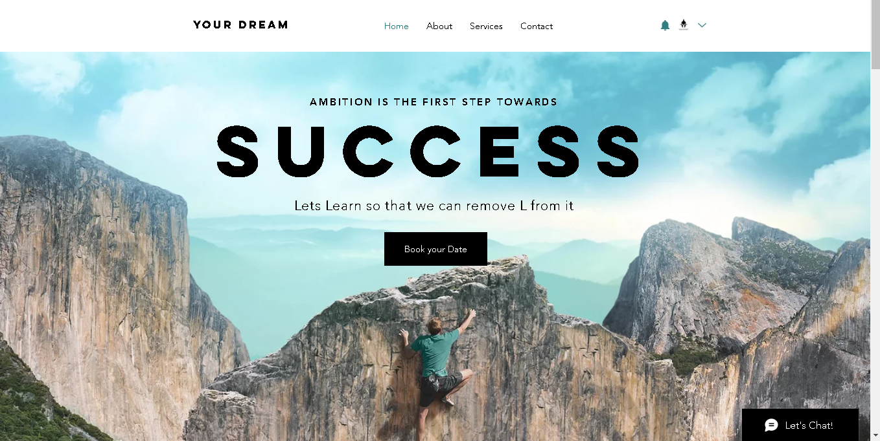

Figure 7‑1: Landing page

1. Login in page:

Figure 7‑2: Register

This is the system where user can sign in to the system if he/she has account on the system and if the user has no account in it there is option for sign un in the section of sign in there is a field for the username or email and it also includes the feature for password saving and also user can sign up by using Google, Facebook,  LinkedIn , or GitHub, at last, there is the option of forgot password if the user has forgotten his login credentials.

About Us:

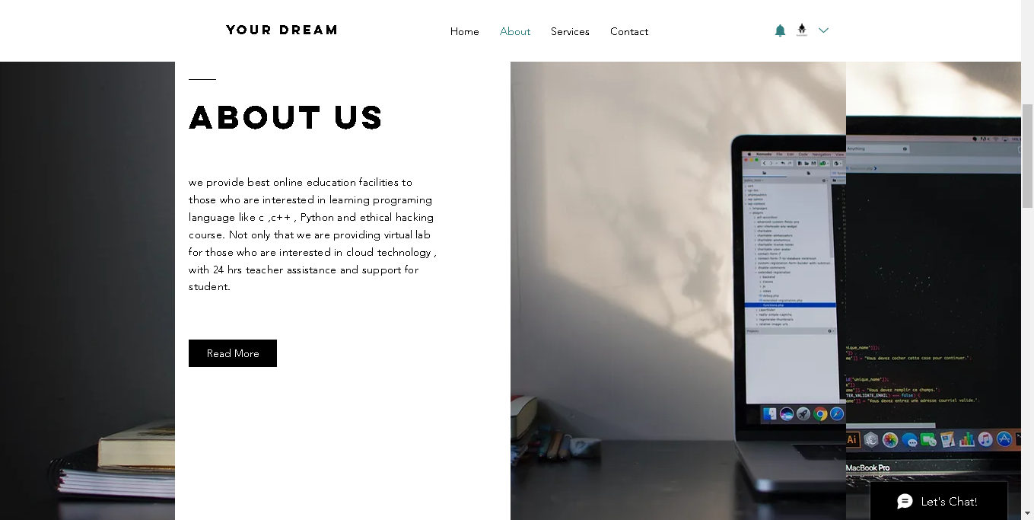

Fig (): About our company

In the about us section, students can learn about the company introduction and history about our company “YOUR DREAM”.

Book a service:

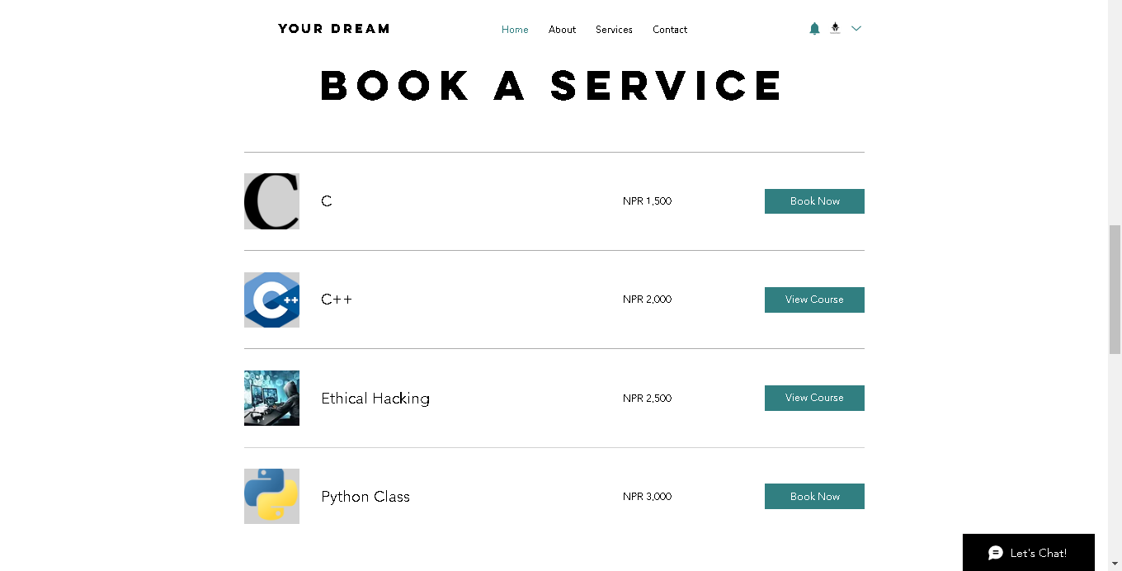

Fig: Book a service

This is a book of service page in which customers can book the services (Book the classes) of C programming language, C++ programming language, Python, and Ethical Hacking classes through the website. To book these classes the customers must pay the given amount which is different for every course. The customers can take one to four courses.

Our Team:

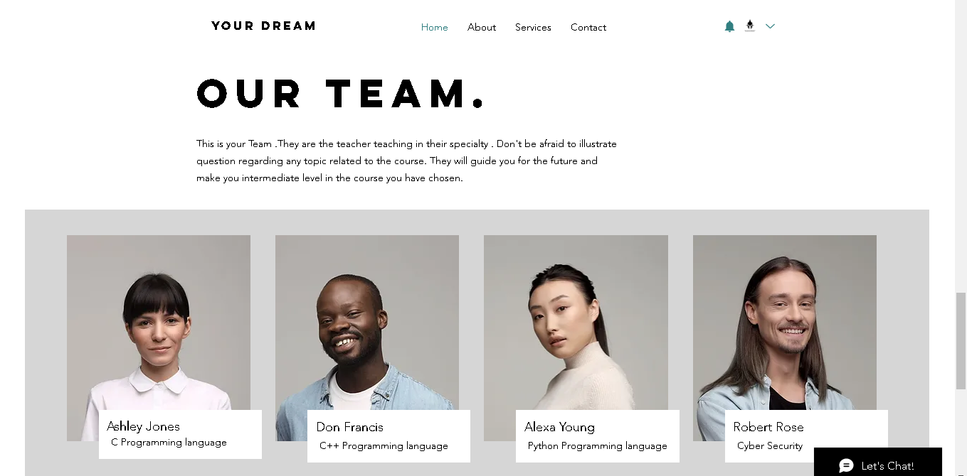

Fig:(): Our team

In our team section, students can learn about the teacher, and they can even search on the internet where our teachers are professional, and they all are experts in their respective fields.

Contact:

It is a page on which students can contact the administrator regarding any course details and they can follow us on various social media sites like Instagram, Facebook, Twitter, LinkedIn, YouTube as well as TikTok.

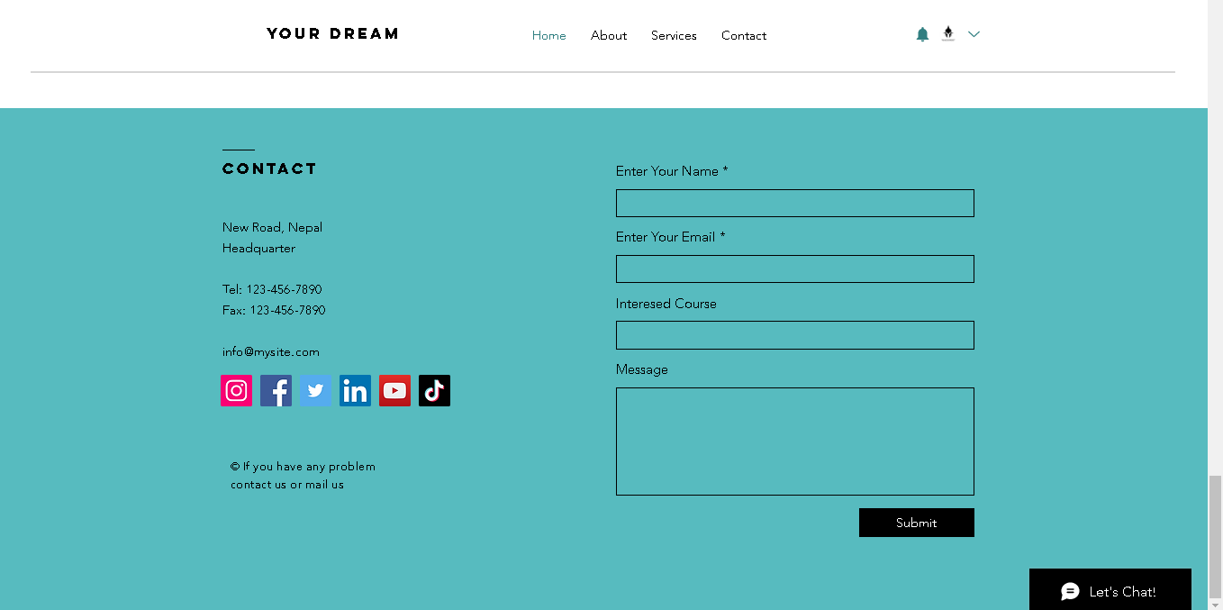

Fig (): Contact page

Chat:

The pop-up chat bottom will appear when you first visit our page.in the pop up message you can ask about your doubts to our AI system which will send you message within short period of time.

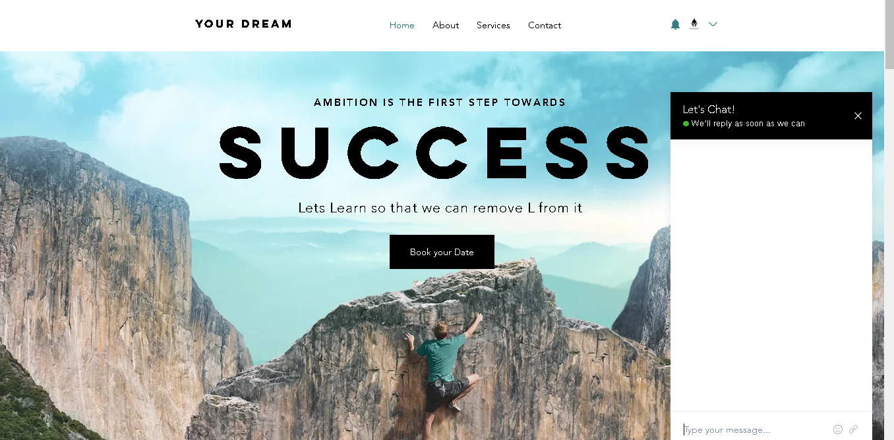

## Admin

As in the admin page, the administration can know about the student performance in the online test and quiz as well as the number of students increasing or decreasing in each section compared to this year and the previous year not only that but the attendance of the student. Admin can know the total sales in the fiscal year.

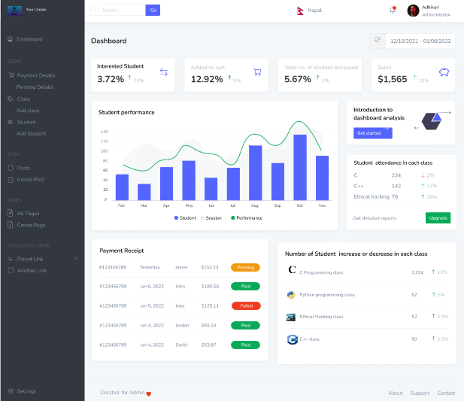

Fig (): admin

## User

This is a useful website panel that can see their progress report send the message and see who has submitted their assignment not only that top student in their class is displayed to encourage students to work hard to display their name at the top of the webpage. The calendar is displayed on the side of the website to see the date and coming days’ events and programs. The upcoming event related to the course is displayed at the bottom left.

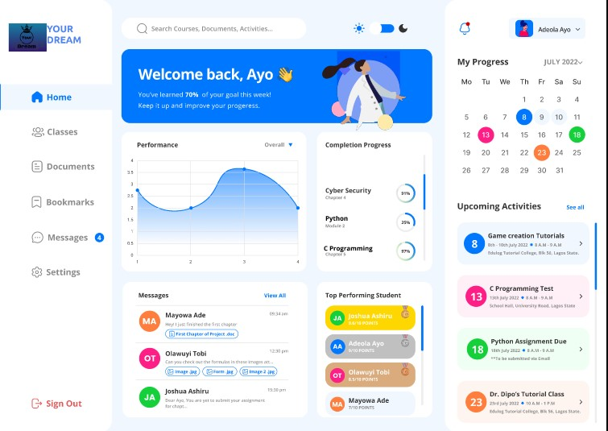

## Teacher

It is a system which is especially built for the teachers to interact with students. Submission uploading is easier in this system. Thus, for e-learning training teachers should take advantage of existing tools to make courses more dynamic, by encouraging the students to utilize the resources to gather the information. The teachers can provide the students with a better learning environment. Thus, this system provides correspondence among the students by giving them the opportunity to improve themselves in an environment where they can fully interact and acknowledge the information.

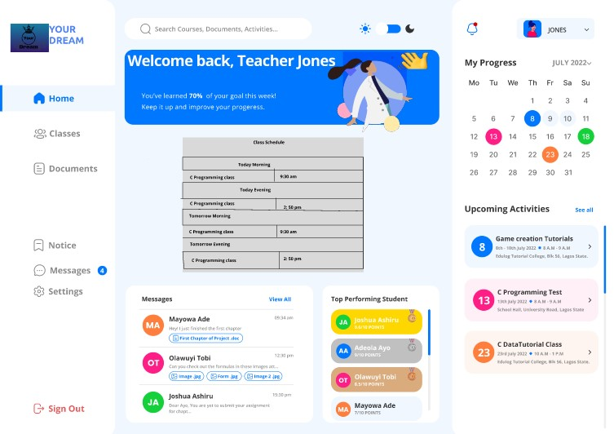

# Requirement Gathering

## Observation

In our system, many of the students and users are not satisfied with its functioning. To observe those kinds of faults we can easily gather some important tips. Our system gives complete guidance for better study courses by providing a better teacher-like system software. If there’s a picture-perfect teacher-like system, then there won’t be a problem regarding the online courses because they will easily understand the courses without any problem. This system provides a real word scenario that provides accurate solutions for every problem which is implicated in the current world or society. Humans can do so many things, but they require some references to their work so to gather or acquire that information they can take a course from our system. It provides a series of solutions of building blocks of every problem from a simple system. It also comes with a video with the solution where there are many talented and qualified teachers through which they describe how things work or provide an effortless solution for the problems. Also, it gives a better explanation of real-life scenarios like teaching how there’s an interaction or negotiation between the CEO and the Manager of the company. The best teaching method for the kids is animation so there’s also a program in our system. Animation helps older students or users also because it is the simplest method through which the users can get information by observing the animation of some solutions. Many people find it harder to understand the language of an actual person that’s why the animation helps to make the video interesting it contains animated characters doing some interesting gestures sign which attracts the kids for watching the video and understand it easily.

Advantages of observation:

The observation related to real world scenario makes quite easy for the users to get the exact solution which makes their work quite effective.

The users and kids can learn new learning skills through observational learning methods like animation and video.

Animation provides a better learning skill for the kids which they get amused by watching the animation and, they’ll learn new things.

The user can get more than the solution by observing it furthermore and searching it in more detailed way.

Disadvantages of Observation:

We cannot get the complete solution only by observing a particular thing.

Observation cannot build up the character like confidence, cannot maintain the discipline of the students.

The students or users residing or living in the rural area can’t get access to the internet through which it makes it difficult to get the information.

It is an online based system through which the user cannot interact with other people and feel quite uneasy and unpleasant towards them.

Conducting Observation:

Observation is necessary for gathering information, though observation helps to maintain certain requirements while conducting some of the reports. The

Data Dictionary

|  |  |  |  |  |  |
| --- | --- | --- | --- | --- | --- |
| S.N. | Attribute | Data type | Nullable | Description | Example |
|  | Report_id(PK) | varchar (10) | No | Identifies the report details with unique id. | Re_007 |
|  | Report_name | varchar (20) | No | Name written in the report. | Payment report |
|  | Report_category | varchar (20) | No | Classification from the given report. | Payment workload |
|  | Report_file_format | varchar (20) | No | Format of the given report in the document. | .docx |
|  | Report_date | date | No | Date written in the report of document. | 2023-03-08 |

## Interview

**An interview is a way of communication between two people where one-on-one interaction takes place. It’s basically for the selection of candidates in a particular company or organization where a discussion or formal conversation between a potential employer and candidate occurs to get possible information for the acknowledgment of candidates and respective organizations. In this methodology, the employer asks questions to candidates to collect one’s requirements for the selection for a job or position. During the interview phase, the interviewer might ask you some basic questions regarding salary expectations, skills, and objectives, whereas you can ask about the job responsibilities. Another purpose of an interview is to seek the opinion of candidates.**

**Method to conduct an interview:**

**Questions to Ask**

**Q) Can you tell me about your experience with e-learning content creation?**

**“As an IT student, I’ve completed many courses from e-learning platforms like Coursera, Skillshare, and Duolingo as well as I’ve developed the ‘Learn Me’ website as a basic e-learning platform during my project year”**

**Q) How do you ensure that your e-learning materials are efficiently effective and helpful for users?**

**“By providing a multimedia resource with real-world examples and daily interactive sessions with the feedback we can ensure the e-learning platform is essentially effective for students.”**

**Q) Have you ever worked with Learning Management System before? How was your experience?**

**“Yes, I was quite familiar with Edmodo while teaching. It’s a free LMS that is widely used in schools, colleges, and universities. It allows teachers to create and helps to manage online classrooms as well as to share study material and resources and helps to share with another teacher.”**

**Q) What is your opinion on ‘Your Dream’ and what do you think that our company’s current issues and how can you help us to overcome them in the future?**

**“As I know it’s one of the leading companies in the E-learning industry with great impact on the student but from my point of view the company is experiencing bad management system and technical support which I think I could bring improvements if I got chance”**

**Advantages of Interview E-Learning management system**

**You can collect accurate information about candidates’ opinions and facts from which you can monitor him/her from close.**

**It’s a good way to create a comfortable environment between employers and managers.**

**By interviewing we can observe one’s vision and idea to develop the company’s strategy to face possible outcomes and deficits**

**The interviewer will be supporting the interviewer during the interview by understanding the intention of their answer and behavior, and body language.**

**Overall, you can select the ideal candidates for the best position.**

**The disadvantage of interview E-leaning management system**

**During the interview process, communication may be lacking, and can’t present their idea properly.**

**There is a short period to completely present your thoughts.**

**Simple communication gaps between the people and the interviewer can create a conflict and loss of perfect candidate.**

**The interviewer given person should be attentive as important details can be missed during giving interview.**

**While interviewing you might lead to come with quick judgment due to less interaction where you can experience uncertain outcomes**

**Dataflow:**

|  |  |
| --- | --- |
| **Name** | **Inform teacher** |
| **Description** | **To inform teacher about schedule** |
| **Source** | **Management** |
| **Destination** | **Teacher** |
| **Data structure name** | **Teacher_id, Class_id** |

**Process:**

|  |  |
| --- | --- |
| **Name** | **Assign trainer** |
| **Description** | **Trainers are assigned their classes by the management and the schedule is given** |
| **Input Dataflow** | **Teacher** |
| **Output Dataflow** | **Inform teacher** |
| **Process Description** | **Teacher = class**  **If teacher = class,**  **Then inform the teacher about the schedule.**  **End if** |

## Document review

Document review means reviewing or investing, analyzing the whole document again and again to gather the information from it and test whether there is any mistake or not. Basically, document review is important everywhere in small businesses, and schools, creating ideas and it also works in our platform eLearning.

So, document review helps us understand what to add and what to not add to our company "YOUR DREAM" or what is the mistake in a document and how can we make this a better document? In a simple way document review means just reviewing the previous document and editing that document and taking the earlier ideas from that document. So, in our company’s eLearning project, it works the same it covers the mistake, edit it, and gathers the required important data from the previous document. Talking about the document review it demands a close checking of the document in a document review to know if they are all working as the measurement of the content properly or not. In this process, every document is properly or detailly covered. To assist decision-making or to adhere to legal or regulatory standards, it is important to make sure that all pertinent information is identified and presented in a clear and structured manner.

Advantages:

1. It will make our document more error-free because it will help to find the error in our previous document and will improve the development of the quality of the document.

2. It will save a lot of time because it will review the document and find the problems in the document early and save from the problems that are going to happen later.

3. It will help to understand the document and find the missing points in the document and

allows adding them.

Disadvantages:

* 1. So, one of the disadvantages is that the person or anybody reviewing the document will only have a limited idea and may not understand what is the purpose or use of that document which will lead to mistakes or errors in that document.

2. Document review will be a time-consuming task as reviewing the document again and again will slow down the process of document reviewing.

3. In the document review process the cost will be high because of the expertise we need for the document review as it needs a high level of skills and knowledge to implement it.

## Form and questioner

For the betterment of the company, we plan to gather information using form and questioner in which we lunched the survey using google form from to site to other student and we have collected some of the response we received from them which are displayed below with the participated information:

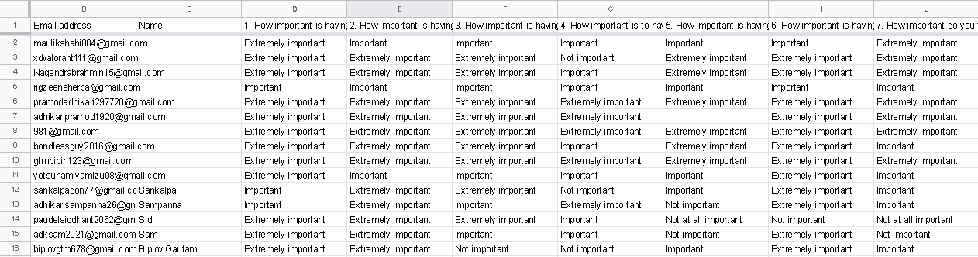

These are the questions we asked our customer and the customer response with the easy to do survey which took less than 3 minutes to complete. The survey can be answered using various devices such as MAC OS, windows even mobile phone.

Some of the merits and demerits of Form and questioner are explained below:

Merits:

* It saves time as information is easy to gather.
* In a short period of time, a user can answer multiple questions.
* Creating and executing surveys are cost-efficient and quick.
* You can easily create and change questions if needed.
* The questions are multiple choice questions so there is less change of bias.
* Users can answer surveys in their free time and without revealing their identity.
* Responses can be compared with historical data.

Demerits:

The demerits of survey and question may depend upon following factor:

* Users may not provide accurate, and honest answers. (DeFranzo, 2023)
* The survey questions are multiple choice questions in which the user can’t present their point of view. (DeFranzo, 2023)
* The user desired question may not be provided in the survey. (DeFranzo, 2023)
* User sometime may not understand why the question is given (DeFranzo, 2023).

Types of questionnaires:

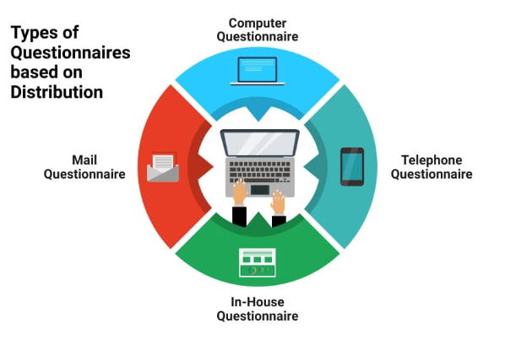

**Dataflow:**

**Process:**

## Question

1. What are the problems regarding the present system?

This is related to internet so the user must have internet for the access of the system to get any information.

1. What’s the objective of the system?
2. Why should you prefer this system rather than the basic way of learning?

# Design

## Design data dictionary

Student

Schedule

## ELF (Entity Life History)

ELF for student:

# Conclusion

At last, we would like to thank APU University to give us this assignment regarding “E-learning”. We’ve gathered various regarding the learning management system. In this whole project, we’ve gathered some of the topics which have met the criteria given in the assignment. We’ve manipulated and collected various data regarding the topic. In our assignment, we’ve maintained the topic and description of our system and its business process. Through the business process, we’ve maintained some details about its objective and the problems with the system. We’ve also scheduled the project division. We’ve given the information about the workload matrix and how the project work has been completed according to the date. We’ve also maintained the feasibility study like operational, technical, economical, etc. After that, some of the parts were so difficult to work out although we managed to complete the whole assignment. Also, we’ve discussed system analysis and gathered the requirements for system analysis. Then, some of our group members equally supported in designing the diagram like the context diagram, DFD level 0, and the ERD diagram. We’ve also designed a website for the assignment describing the role of each section. Then we gathered some information regarding some of the points that are constantly asked by the user and gave the solution for those problems. In the end, we’ve designed a data dictionary that keeps all the data of the system. Also, we would like to thank these websites which are given as references that helped in the completion of our assignment by guiding us.

# References

bartleby. (2023, 03 19). *Effects Of Lack Of Resource Materials For Students*. Retrieved from bartleby: https://www.bartleby.com/essay/Effects-Of-Lack-Of-Resource-Materials-For-PKVCHVEBHEF

bcisnotes. (2020, Feb 20). *PIECES Framework || The Context of System Analysis and Design || Bcis Notes*. Retrieved from bcisnotes: https://bcisnotes.com/thirdsemester/system-analysis-and-design/pieces-framework/

DeFranzo, S. E. (2023, March 19). *Advantages and Disadvantages of Surveys*. Retrieved from snapsurveys: https://www.snapsurveys.com/blog/advantages-disadvantages-surveys/

elearningindustry. (2023, 03 19). *Lack Of eLearning Materials In Secondary Schools*. Retrieved from elearningindustry: https://elearningindustry.com/lack-of-elearning-materials-secondary-schools#:~:text=Inadequate%20technology%20infrastructure.,Consideration%20of%20eLearning%20policies

LISBDNETWORK. (2022, February 11). *Information Gathering*. Retrieved from lisedunetwork: https://www.lisedunetwork.com/information-gathering/

open. (2023, 03 19). *Purpose of teaching and learning materials*. Retrieved from open: https://www.open.edu/openlearncreate/mod/page/view.php?id=168509#:~:text=Learning%20materials%20can%20significantly%20increase,new%20skill%20gained%20in%20class

Simplilearn. (2023, 2 3). *Feasibility Study and Its Importance in Project Management*. Retrieved from Simplilearn: https://www.simplilearn.com/feasibility-study-article